|  |
| --- |
| IALA Guideline |

Gnnnn

Light Measurement

Edition x.x

Date (of approval by Council)

urn:mrn:iala:pub:gnnnn

Revisions to this document are to be noted in the table prior to the issue of a revised document.

|  |  |  |
| --- | --- | --- |
| Date | Details | Approval |
|  |  |  |
|  |  |  |
|  |  |  |
|  |  |  |
|  |  |  |
|  |  |  |
|  |  |  |

1. Introduction 5

2. DEfinitions 5

3. Standard measurement conditions 5

3.1. measurement geometry 5

3.2. Ambient conditions 6

3.3. POWER SUPPLY CONDITIONS 6

4. Measurement preparation 6

4.1. Mounting 6

4.2. Warm-up 6

4.3. Measurement distance 6

5. Mesurement of marine signal lights 7

5.1. Luminous Intenisty versus angle 7

5.1.1. measurement method/procedure 7

5.1.2. Vertical Divergence 7

5.1.3. Horizontal Divergence 8

5.1.4. Specification Peak Intensity 8

5.2. Luminous intenisty versus time 8

5.2.1. mearement method/procedure 8

5.2.2. Flash Duration 8

5.2.3. Effective Intensity 8

5.2.4. Nominal Range 8

5.3. Colour and Sectors 8

5.3.1. mearement method/procedure 8

5.3.2. Signal Colour 9

5.3.3. Sector Colour Boundary 9

5.3.4. Sector Intensity Boundary 9

5.3.5. Sector Width 9

5.3.6. Sector Boundary 9

5.3.7. Sector of Uncertainty 9

6. abbreviations 9

7. references 9

8. Further reading 9

APPENDIX 1 Further Technical Guidance 10

1. The Measurement Laboratory 10

1.1. Stray and ambient light control 10

1.2. Folded Path Measurement 10

1.3. Zero Length Measurement 10

2. The Device Under Test 10

2.1. Reference center 10

2.2. SettingsSpectral correction 10

3. Photometry 10

3.1. Photometric distance law 10

3.2. Measurement by Photometer 10

3.3. Measurement by Spectroradiometer 10

3.4. Calibration by Substitution with Calibrated Light Source 10

3.5. Calibration using Known Distance 10

3.6. Relative Photometry of Optical Systems 11

3.7. Measurement of Luminous Flux 11

3.8. Measurement of Modulated Light 11

3.9. The convolution to determine flash duration 11

4. Colourimetry 11

4.1. Measurement by Spectroradiometer 11

4.2. Measurement by Tristimulus Colourimeter 11

5. Measurment in the Field 11

5.1. Mesurement of charater of AtoN light based on spectral analysis 11

5.2. Mesurement of AtoN light based on image processing technology 11

5.3. Mesurement based on prisms and prisim frame 11

List of Tables

*Table 1* Example Elevation Profile Summary 8

List of Figures

Figure 1 X-Y Coordinate System 5

Figure 2 Example luminous intensity versus elevation profile 6

# Introduction

This guideline supports IALA Recommendation R0203 Definitions of Marine Signal Lights Terms of Measurements [1]. The main body provides further explanations, diagrams and examples to the recommendations given in R0203. They will cover the measurements as well as both processing and presentation of results. These sections are intended for measurement operators with some experience.

An appendix contains further information including introductory topics, aimed at those newer to light measurement, and more detailed topics to assist readers in obtaining accurate and precise measurements. However, it is unfeasible for a single document to transfer all knowledge and skills required. It is recommended that measurement personnel complete dedicated training courses and read additional material.

# DEfinitions

# Standard measurement conditions

## measurement geometry

R0203 recommends an X-Y coordinate system. This system is illustrated in Figure 1. The system has the following characteristics:

* The coordinates at the datum position are X = 0° and Y = 0°.
* The X coordinate is the rotation of the DUT about a vertical axis.
  + Rotating the DUT clockwise increases the value of X up to a maximum of 180°.
  + Rotating the DUT anticlockwise decreases the value of X down to a minimum of -180°.
  + The X angle is often referred to as the “horizontal” or “azimuth” angle since the rotation occurs in the horizontal plane.
* The Y coordinate is the rotation of the DUT about a horizontal axis that is perpendicular to the measurement path. Viewing with the measurement sensor to the right of the DUT as in Figure 1:
  + Rotating the DUT clockwise increases the value of Y up to a maximum of 180°.
  + Rotating the DUT anticlockwise decreases the value of Y down to a minimum of -180°.
  + The Y angle is often referred to as the “vertical” or “elevation” angle since the rotation occurs in the vertical plane.
* The axis of rotation and measurement path should intersect. The centre of the DUT should be positioned at this intersection.

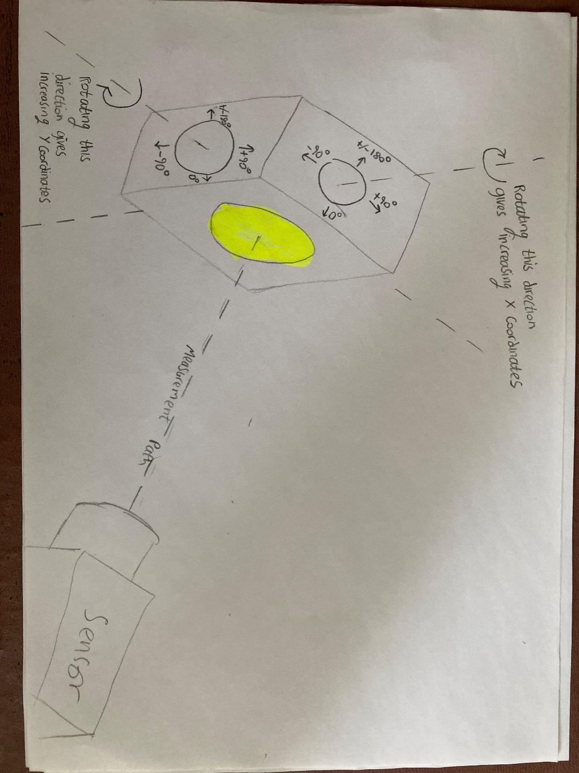

1. X-Y Coordinate System

## Ambient conditions

## POWER SUPPLY CONDITIONS

# Measurement preparation

## Mounting

## Settings

## Warm-up

## Measurement distance

# Measurement of marine signal lights

## Luminous Intenisty versus angle

### measurement method/procedure

### Vertical Divergence

R0203 gives the following definition:

“The average of all measured Full Width Half Maximum (FWHM) values shall be reported as the vertical divergence, along with the maximum deviation of the maximum intensity from an elevation of Y = 0°.”

These parameters are calculated from a light’s luminous intensity versus elevation angle profiles. An example profile plot, annotated with the FWHM, is shown in Figure 2.

An example summary of three elevation profiles is shown in Table 1. In this example three elevation profiles are summarised, each taken at a different azimuth coordinate. The first row of results corresponds to the profile shown in Figure 2; these should be compared to aid understanding.

The FWHM is the angle between the points where the plot crosses 50 % of the peak intensity. It is possible that the intensity of the plot drops below 50 % of the peak and then rises above, giving multiple crossing points. In this situation, the innermost angle on each side of the peak is used.

Table 1 shows the angle at which the maximum intensity occurs in each elevation profile. The angle with the greatest magnitude (positive or negative) is presented as the maximum deviation of the maximum intensity from an elevation of Y = 0°.

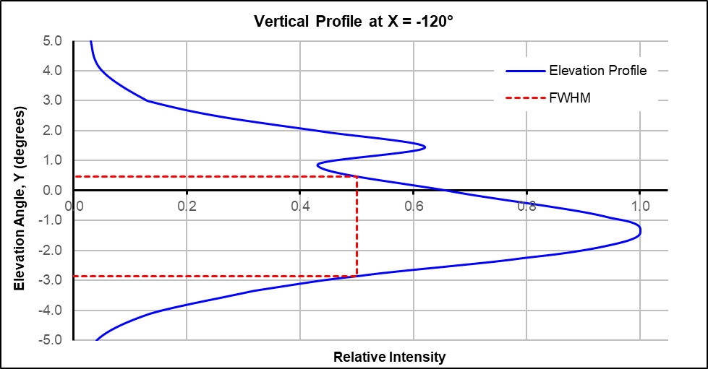

1. Example Luminous Intensity Versus Elevation Profile
2. Example Elevation Profile Summary

|  |  |  |
| --- | --- | --- |
| Azimuth Measurement Angle (X) | FHWM | Angle of Maximum Intensity. |
| -120° | 3.35° | -1.30° |
| 0° | 2.95° | -0.45° |
| 120° | 3.05° | 0.15° |
|  |  |  |
| Vertical Divergence | 3.12° |  |
| Maximum deviation from 0° |  | -1.30° |

**Additional guidance to add:**

**Number of profiles to measure for**: Omni Directional lantern, Sector Light, Directional/Rotating Light

**Normalisation** This profile has been normalised, to the peak of the beam. This normalisation is optional and each lighthouse authority may choose whether to present absolute intensity values, normalise and what to normalise to.

### Horizontal Divergence

### Specification Peak Intensity

## Luminous intenisty versus time

### mearement method/procedure

### Flash Duration

### Effective Intensity

### Nominal Range

## Colour and Sectors

### measurement method/procedure

### Signal Colour

### Sector Colour Boundary

### Sector Intensity Boundary

### Sector Width

### Sector Boundary

### Sector of Uncertainty

# abbreviations

DUT Device Under Test

# references

1. IALA. (2022) Recommendation R0203 Definitions of Marine Signal Lights Terms of Measurement.

# Further reading

Any texts that are recommended to the reader without direct reference in the text should be listed within this section using the same syntax as the reference list. Sources should be listed using the **Further reading** style.

1. Einstein, A. (1905) Relativity: The Special and General Theory of Relativity
2. Idle, E. (1984) The Galaxy Song
3. Further Technical Guidance
   1. The Measurement Laboratory
      1. Overview
      2. Stray and ambient light control
      3. Folded Path Measurement
      4. Zero Length Measurement
   2. The Device Under Test
      1. Reference center
   3. Photometry
      1. Photometric distance law
      2. Measurement by Photometer
         1. Spectral Correction Factor
      3. Measurement by Spectroradiometer
      4. Calibration by Substitution with Calibrated Light Source
      5. Calibration using Known Distance
      6. Relative Photometry of Optical Systems
      7. Measurement of Luminous Flux
      8. Measurement of Modulated Light
      9. The convolution to determine flash duration
   4. Colourimetry
      1. Measurement by Spectroradiometer
      2. Measurement by Tristimulus Colourimeter
   5. Measurement Equipment Requirements
      1. Photometer
      2. Spectroradiometer
      3. Colouromiter
   6. Measurement in the Field
      1. Measurement of character of AtoN light based on spectral analysis
      2. Measurement of AtoN light based on image processing technology
      3. Measurement of Vertical Profile Using prisms